**Ideation Phase**

**Empathize & Discover**

|  |  |
| --- | --- |
| Date | 05 september2023 |
| Team ID | NM2023TMID19094 |
| Project Name | Intelligent garbage classification using deep learning |
| Maximum Marks | 4 Marks |

**Empathy Map Canvas:**

An empathy map is a simple, easy-to-digest visual that captures knowledge about a user’s behaviours and attitudes.

It is a useful tool to helps teams better understand their users.

Creating an effective solution requires understanding the true problem and the person who is experiencing it. The exercise of creating the map helps participants consider things from the user’s perspective along with his or her goals and challenges.

Design Thinking is a human-centered approach extensively used across different domains that aims at problem solving, value creation for stakeholders and innovation by fostering creativity. The most characterising and critical step along the Design Thinking process is the empathy phase, in which stakeholder analysis is performed by looking at a given scenario from the perspective of different stakeholders. Such a methodology enables a systematic information gathering and organization that results in a deep understanding of actual problems, needs and expectations from the target stakeholders. The uniqueness of problems and the need for situation-specific data makes knowledge re-use not always practical, even within the most consolidated and experienced environments. In this paper we propose an ontological support to empathy mapping that aims to

(i)establish an interoperable fine-grained data layer among the different data collected throughout the empathy mapping process,

(ii) enable multi-scenario analysis underpinned by formal specifications .

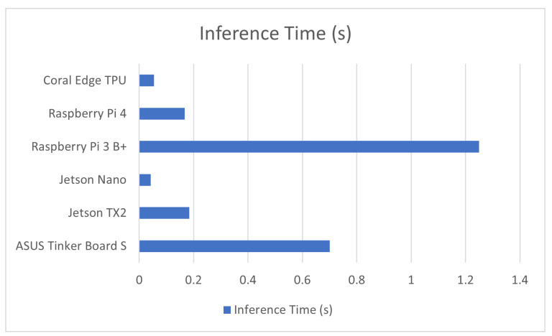 (iii) further empower the process through semantic enrichment and integration of insight from multiple sources and contexts. We believe this is the first step to design and properly integrate effective computational and AI-based functionalities along the creative design thinking process, as well as to enable in practice richer and more sophisticated approaches (e.g. through social networks).

**Example:**

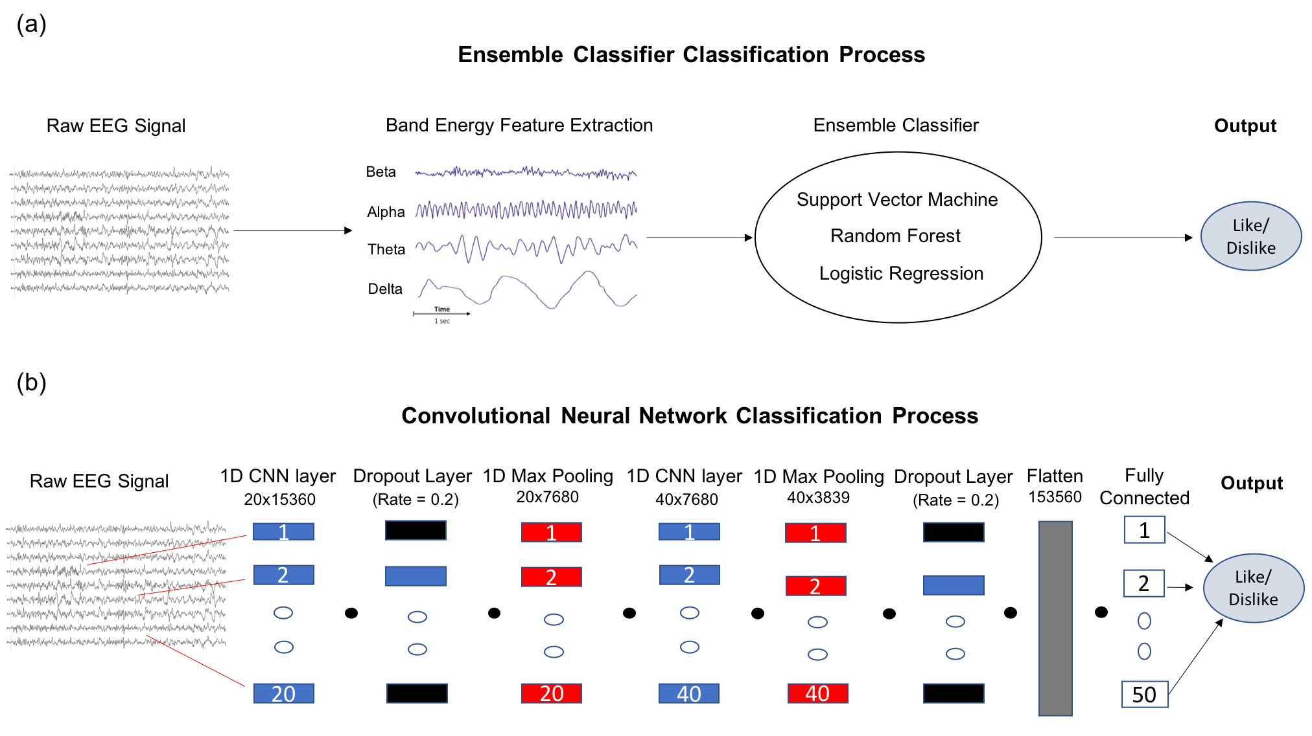Reference: **https://doi.org/10.1145/3460881.3460930**

**Example:semble classiffier classification process**